# 

# 

# 

# Team Tetrahedron

Milestone #3 - Conceptual Model



Team members:

Lauro Fialho Müller

Chandan Radhakrishna

Raghava Vinaykanth Mushunuri

Kavya Vajja

Arnab Das

Anjan Chatterjee

12.05.2020

# Table of contents

Overview 1

Conceptual Model 1

Am Fuchsberg - Erich-Weinart-Str. 2

Leipzigerstr. 3

Traffic lights 4

The Assumptions 4

The Data 5

The Experiments 5

Cost overview 6

Future work 7

# Overview

The conceptual model is designed in this milestone. The main motivation here is to draw a conceptual model that is an abstract representation of the node to be simulated.

# Conceptual Model

In order to facilitate comprehension, we have split the model into three submodels: (1) the behavior in Leipzigerstr., (2) the behavior in Am Fuchsberg - Erich-Weinart-Str., and (3) the traffic lights. The models are presented below, together with a dedicated link for opening the details of the model in a larger version.

## Am Fuchsberg - Erich-Weinart-Str.

[Link to expanded version](https://drive.google.com/file/d/1H-5AYENZVi4KkSXmePU64awU75YrtE1o/view?usp=sharing)

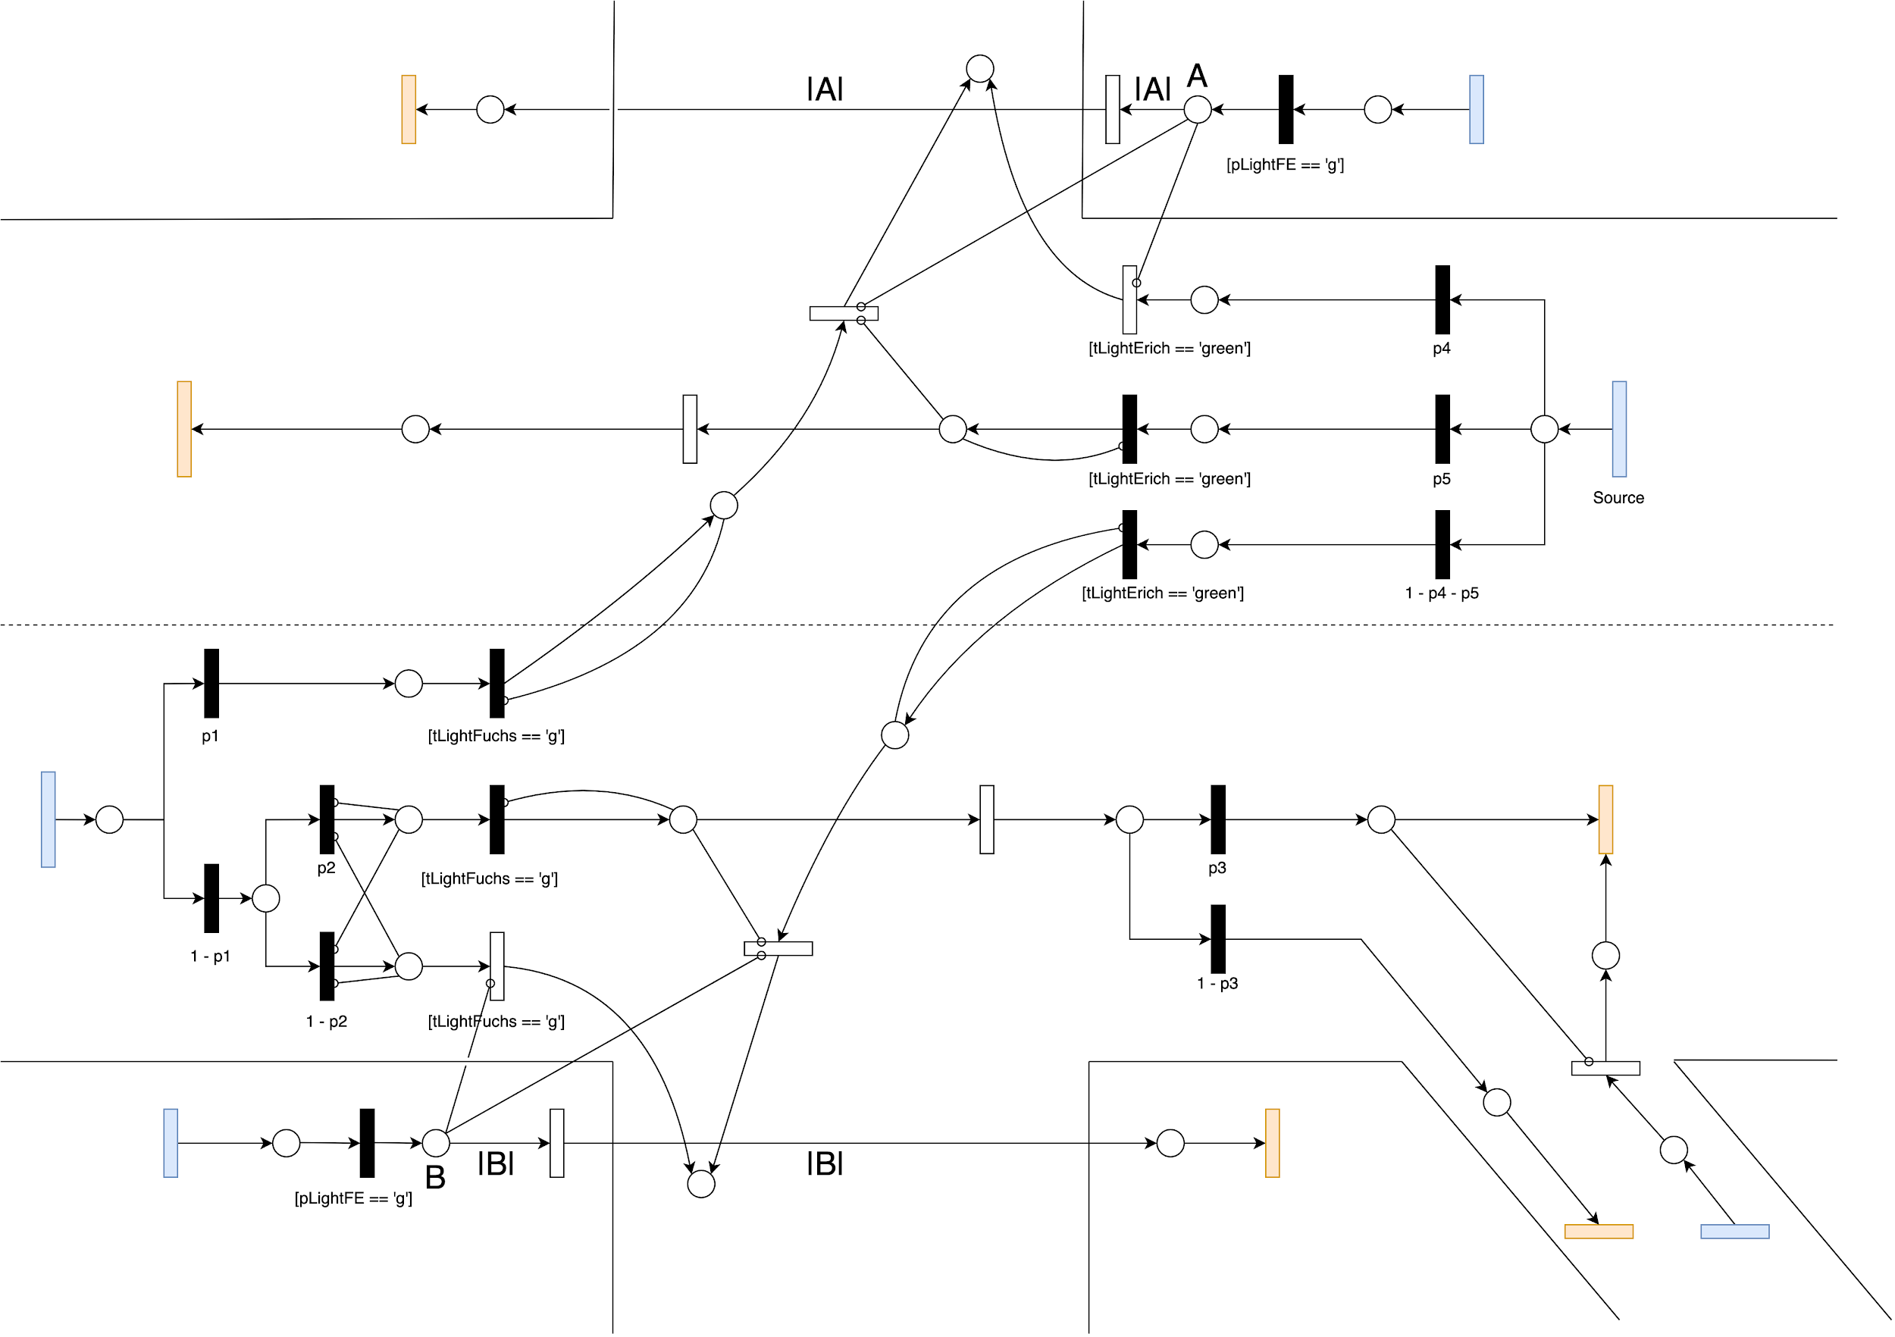

## Leipzigerstr.

[Link to expanded version](https://drive.google.com/file/d/1LMtk_mSanhWzyFVZUG3IMCI-OLOaRme6/view?usp=sharing)

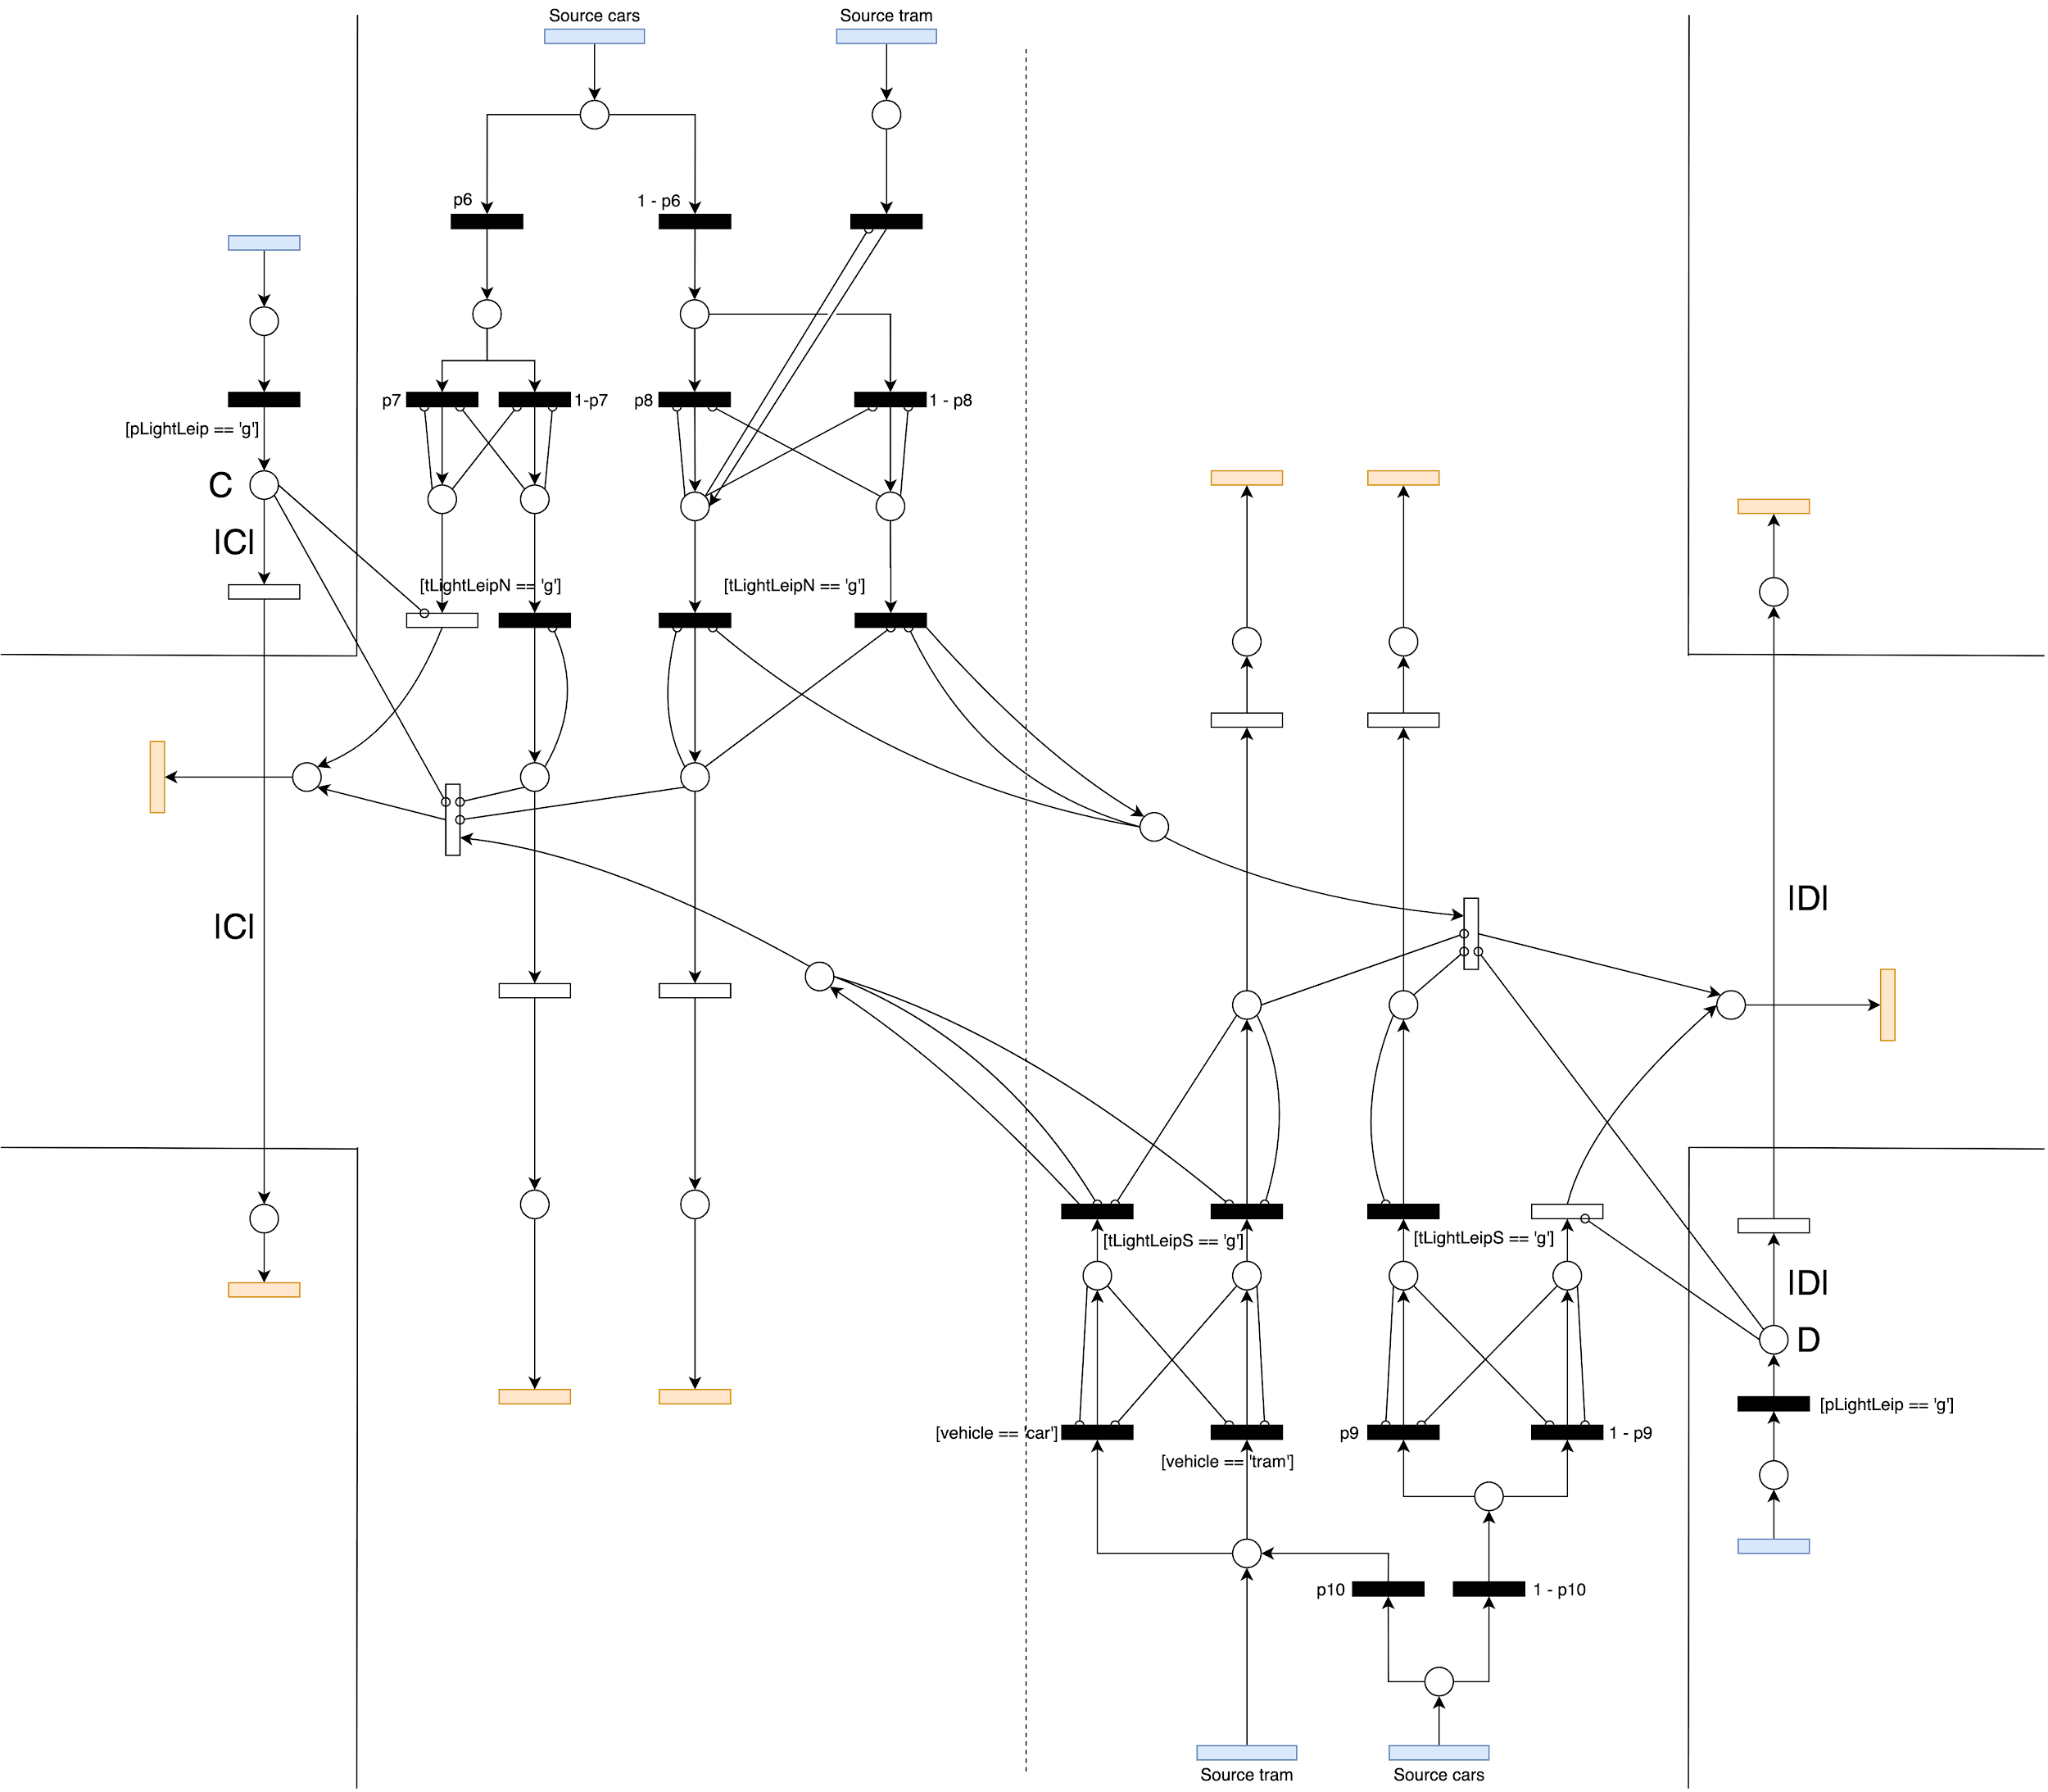

## Traffic lights

[Link to expanded version](https://drive.google.com/file/d/1A6x7FhajYgcASWRywRCvvDn0v_5_uD2M/view?usp=sharing)

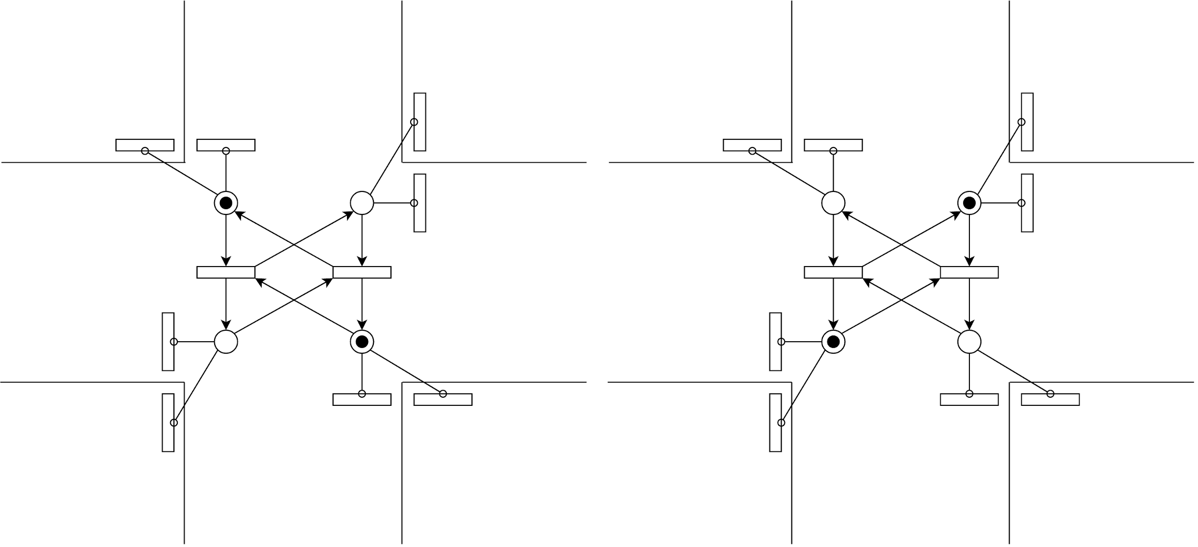

# The Assumptions

The assumptions represent the simplifications done on the model, to make it simple and easy to represent.

1. We assume all the motor vehicles are of the same type.
2. We assume all pedestrians and cyclists behave in the same way.
3. Pedestrians go in only one direction. We will model different sources for each of the possible directions.
4. We assume there are no major changes in the behavior of cars and pedestrians between different years.
5. When trams and cars both come together, trams are given higher precedence.

# The Data

This section talks about the data being measured as input and data being used as simulation results.

1. The quantities to be measured as input
   1. Interarrival times of cars.
   2. Number of cars going in each direction.
   3. Traffic light duration.
   4. Tram timings, tram and cars alternation.
   5. Interarrival times of pedestrians and cyclists.
   6. Time to cross the street.
2. The quantities to be used as simulation results
   1. Average cars between source and sink.
   2. Queue Lengths for each lane.
   3. Average time the car takes to travel from source and sink.
   4. Amount of cars passing through a transition.

# The Experiments

This section talks about the experiments to be performed.

1. Vary traffic light duration.
2. Open traffic lights for each direction in different phases.
3. Include a free lane to turn right for cars from Leipziger str. to Erich-Weinert str.
4. Allow car traffic on the blocked tram line in Leipziger Str.
5. Overload the system and check the behaviour of the traffic.
6. Bridge for cars going straight in Erich-Weinert-Straße / Am Fuchsberg.

# Cost overview

The chart below presents a two-dimensional breakdown of costs, aggregated by both milestone and individual members.

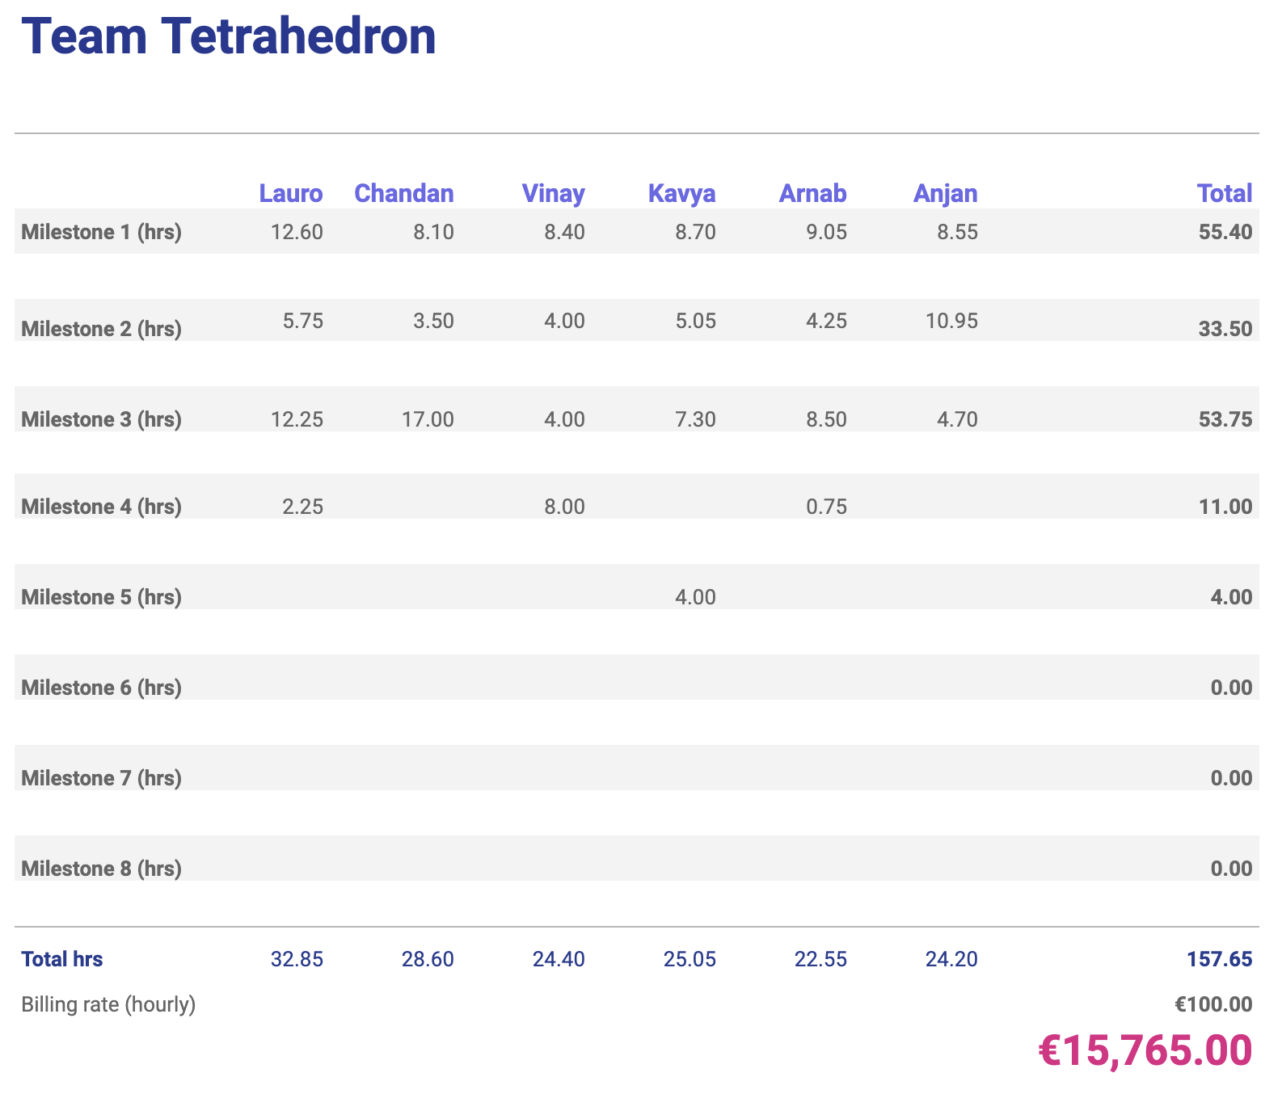

Additionally, the chart below shows the cumulative cost of the project so far. The orange bars represent the planned milestone costs, and the blue line the planned cumulative cost. The green bars represent the actual milestone costs, and the red line the actual cumulative cost.

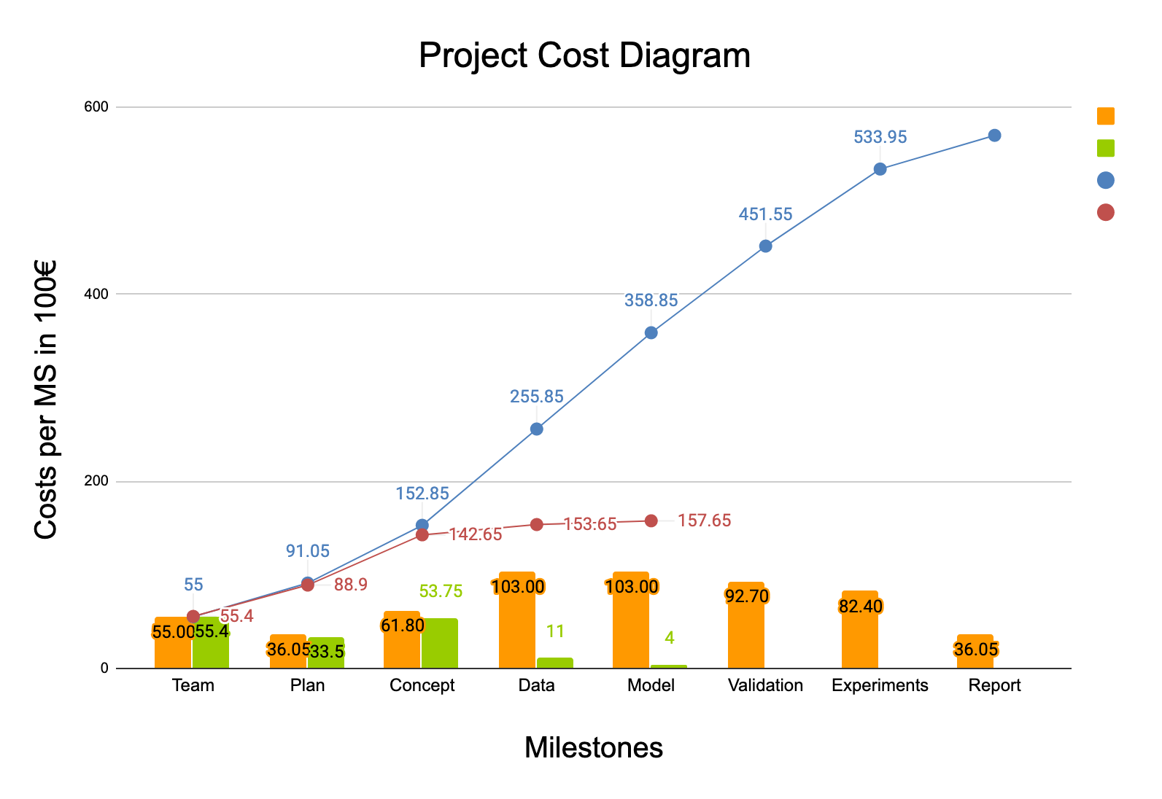

# Future work

We plan to complete analysing data from the city of magdeburg and from the data we got from the previous years. We also plan to complete some part of the simulation model on AnyLogic and parallelly start the verification process as well.